ИП Бошняк В.М.
ИНН 583800016850
г. Пенза, ул. Володарского, д. 83
тел.: +79023522007, 8 (8412) 54-40-80
email: hokens3@gmail.com, muzatrading@mail.ru, http://vk.com/hokens, www.hokens.ru
Режим работы: пн-пт (10:00 - 19:00), сб-вс (10:00 - 16:00)

Контроллер
No. | Pictures | Model | Item Name | Specification | Дилер | Notes | Розница
1 | 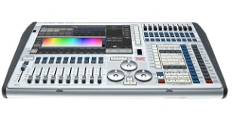 |  | DMX Console | Tiger Touch with flycase | $3 458,00 |  | $4941,00
2 | 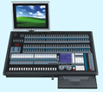 |  | DMX Console | Avolite Expert with flycase | $3 587,00 | The price is without LCD Display, with LCD display + USD 87 | $5 124,00
3 | 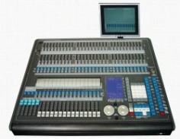 |  | DMX Console | Avolite 2010 with flycase | $2 070,00 | The price is without LCD Display, with LCD display + USD 87 | $2957,00
4 | 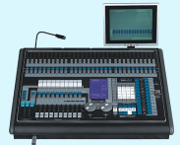 |  | DMX Console | Avolite Tiger with flycase | $1851,00 | The price is without LCD Display, with LCD display + USD 87 | $2 645,00
5 | 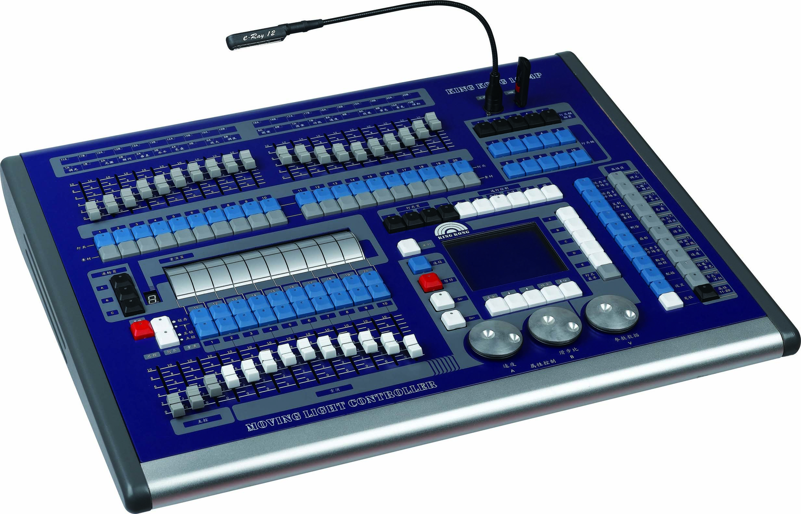 | DMX-1024P | DMX Console | DMX512 / 1990 standard, maximum 1024 DMX control channel, optically isolated signal output.  Maximum control 96pcs computer lighting or 96CH dimming, use Pearl'library.  Built-in graphics trajectory generator, there are 135 built-in graphics, user-friendly graphical fixtures trajectory control, such as a circle, spiral, rainbow, chase and other effects. Graphics parameters (such as: amplitude, speed, interval, waves, direction) can be set independently.  60 repeat scenes, scenes for storing multi-step and single-step scene. Multi-step scenario can store up to 600 steps.  Backlit LCD display, display in English and Chinese  Off data retention.  U-disk backup and upgrade.  Professional gooseneck lights for indoor and outdoor performances. (Optional)  Power: AC 100- 240V / 50-60Hz.  Size: 485 x 420 x 105. | $1 254,00 | The price is without flightcase, with flightcase+ USD 87 | $1 791,00
6 | 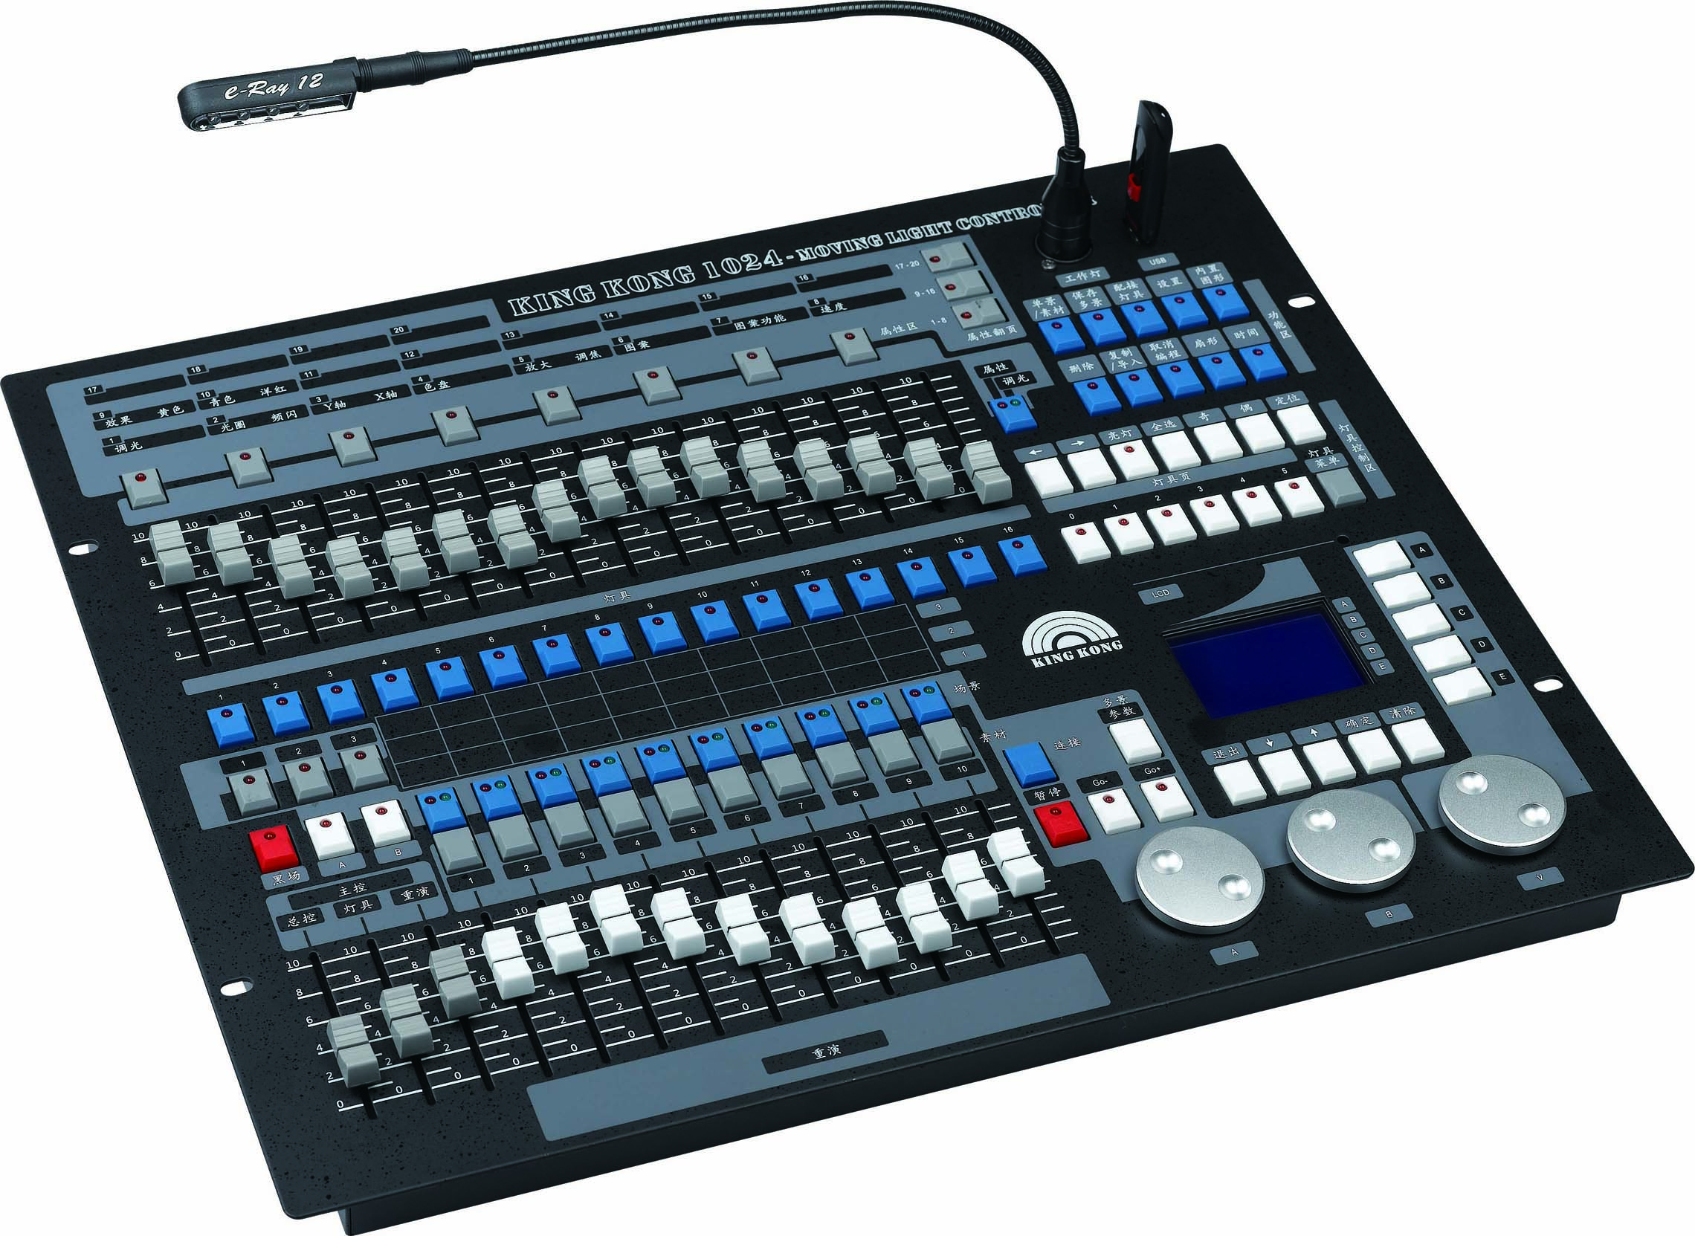 | DMX-1024 | DMX Console | DMX512 / 1990 standard, maximum 1024 DMX control channel, optically isolated signal output.  Maximum control 96pcs computer light or 96ch dimming, use pearl'library.  Built-in graphics traject cory generator, there are 135 built-in graphics, user-friendly graphical fixtures trajectory control, such as a circle, spiral, rainbow, chase and other effects. Graphics parameters (such as: amplitude, speed, interval, waves, direction) can be set independently.  60 repeat scenes, scenes for storing multi-step and single-step scene. Multi-step scenario can store up to 600 steps.  Backlit LCD display, display in English and Chinese  Off data retention.  U-disk backup and upgrade.  Professional gooseneck lights for indoor and outdoor performances. (Optional)  Power: AC 100- 240V / 50-60Hz.  Size: 485 x 420 x 105 | $775,00 | The price is without flightcase, with flightcase+ USD 58 | $1 107,00
7 | 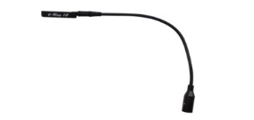 |  |  | LED goose-neck lamp, flexible to adjust to any angle, DC12V | $25,00 |  | $36,00
8 | 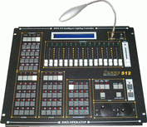 | DMX-1317 | Sunny DMX512 Console | DMX512/1990 standard, 512 DMX control channels  4 output with optical isolated withstand 2000Vrms.  16 sliders for channel, 1 slider for speed control.  16Bit control for absolutely precise movement. | $428,00 |  | $611,00
9 | 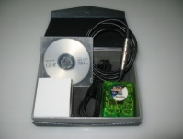 | SL 2048FC |  | SUNLITE DMX Software | $237,00 |  | $338,00
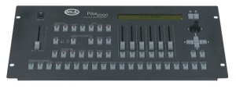  10 |  | Pilot 2000 | DMX Console | Universal DMX controller for 40 units with a maximum of 36 channels each | $269,00 |  | $384,00
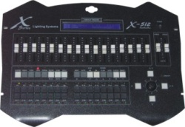  11 |  | DMX-512A | DMX Console | DMX512/1990 Standard, 512 channels  LCD display with backlight  assignable joystick for easy of movement ,four keys fine adjustment  Manual operation enable  32 chases (Maxium 120 steps of each chase), total 3840 chase steps  Range of speed time 0.04s-10m  Chase speed and cross time can be saved automatic  Music trigger source can be selected  8 chases and 32scenes can be run at the same time | $383,00 | Control 32pcs lights at 16 CHLS | $547,00
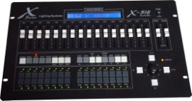  12 |  | DMX-512B | DMX Console
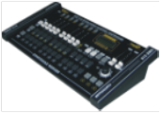  13 |  | DMX 2024 | CROCODILE 2024 DMX Console | DMX512/1990 Standard, 504 channels  LCD display with backlight  8 sliders for manual control of channels  assignable joystick for easy of movement  Manual operation enable  12 chases (Maxium 40 steps of each chase), total 480 chase steps  Chase speed and cross time can be saved automatic | $159,00 | Control 20pcs lights at 24 CHLS and 24 Dimmer CHL | $227,00
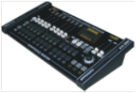  14 |  | DMX 2416 | CROCODILE 2416 DMX Console | DMX512/1990 Standard, 408 channels  LCD display with backlight  8 sliders for manual control of channels  assignable joystick for easy of movement  Manual operation enable  12 chases (Maxium 40 steps of each chase), total 480 chase steps  Chase speed and cross time can be saved automatic | $159,00 | Control 24pcs lights at 16 CHLS and 24 Dimmer CHL | $227,00
15 | 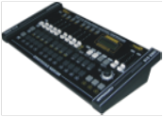 | DMX 1216 | CROCODILE 1216 DMX Console | DMX512/1990 Standard, 240 channels  LCD display with backlight  8 sliders for manual control of channels  assignable joystick for easy of movement  Manual operation enable  12 chases (Maxium 40 steps of each chase), total 480 chase steps  Chase speed and cross time | $134,00 | Control 12pcs lights at 16 CHLS and 24 Dimmer CHL | $191,00
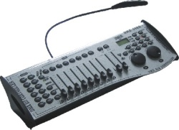  16 |  | DMX-240A | DMX Console | 12 scanners of 16 channels each, total 192 output channels  30 banks have 8 programmable scenes each  6 programmable chase have 240 scenes each  file download allows data be sent between 2 units  auto mode program speed and fade time can be controlled  fade time/assign fade time  blackout master button  LED lamp be included  DMX-240A fine adjustment for Wheel pan and tilt  DMX-240B fine adjustment for joystick pan and tilt | $98,00 | Control 12pcs lights at 16 CHLS | $140,00
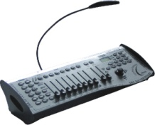  17 |  | DMX-240B | DMX Console
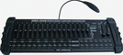  18 |  | DMX-384A | DMX Console | DMX512/1990 Standard ,Total 384 output channels  Control 12pcs DMX lighting fixtures with 32 DMX channel each (DMX-384A)  Control 24pcs DMX lighting fixtures with 16 DMX channel each (DMX-384B)  30 banks have 8 programmable scenes each  6 programmable chase have 240 scenes each  16 slider for manual control of channels (Page A/B)  Run last CHASE or BANK continouse when power on again  Midi control over banks, chases and blackout  Record up to 6 programmable chases with fade time and speeds adjustable  LED program display Midi control over banks, chases and blackout  Built in microphone for music trigerring  Auto mode program fade time can be controlled | $109,00 | Control 12pcs lights at 32 CHLS | $155,00
19 |  | DMX-384B | DMX Console |  | $109,00 | Control 24pcs lights at 16 CHLS | $155,00
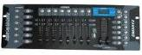  20 |  | DMX 192B |  | 192CH DMX Controller, control 12pcs 16CH light | $49,00 |  | $69,00
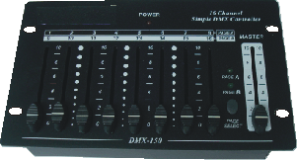  21 |  | DMX-1320 | 16 Channel Simple DMX Controller | Compact and portable device  DC9V adapter and simple build-in battery for instant and convenient use.  Master slider can adjust the values of 1~8 channels, and it provides total control towards overall DMX output.  This button allow you to select Page A (1-8 channels) and Page B (9-16 channels) to extend total control channels be 16 channels | $56,00 |  | $80,00
22 | 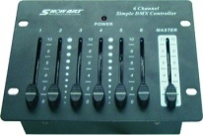 | DMX-1321 | 6 Channel Simple DMX Controller | Compact and portable device  DC9V adapter and simple build-in battery for instant and convenient use.  Master slider can adjust the values of 1-6 channels and provides total control towards overall DMX output.  Faders 1-6 provide direct control over the corresponding dimmers and the intensity for | $49,00 |  | $69,00
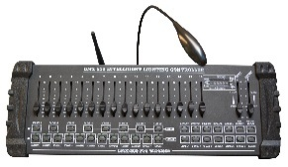  23 |  | DMX-200W | 2.4G Wireless DMX512 Controller | DMX512/1990 Standard ,Total 192 output channels  30 banks have 8 programmable scenes each  6 programmable chase have 240 scenes each  16 slider for manual control of channels  Midi control over banks, chases and blackout  Record up to 6 programmable chases with fade time and speeds adjustable  LED program display Midi control over banks, chases and blackout  Built in microphone for music trigerring  Auto mode program fade time can be controlled  LED lamp be included  Standard DMX512 Signal, 2.4G Wireless DMX512 transmitter  Communication Distance: 300m ( visible distance) | $122,00 |  | $175,00
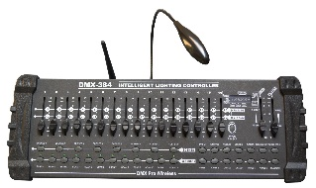  24 |  | DMX-384A-W | 2.4G Wireless DMX512 Controller | DMX512/1990 Standard ,Total 384 output channels  Control 12pcs DMX lighting fixtures with 32 DMX channel each (DMX-384A)  Control 24pcs DMX lighting fixtures with 16 DMX channel each (DMX-384B)  30 banks have 8 programmable scenes each  6 programmable chase have 240 scenes each  16 slider for manual control of channels (Page A/B)  Run last CHASE or BANK continouse when power on again  Midi control over banks, chases and blackout  Record up to 6 programmable chases with fade time and speeds adjustable  LED program display Midi control over banks, chases and blackout  Built in microphone for music trigerring  Auto mode program fade time can be controlled  LED lamp be included  Standard DMX512 Signal, 2.4G Wireless DMX512 transmitter  Communication Distance: 300m ( visible distance) | $134,00 |  | $191,00
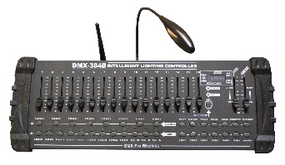  25 |  | DMX-384B-W |  |  | $134,00 |  | $191,00
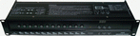  26 |  | DMX-1306 | DMX switch box | DMX512/1990 Standard, 12 channels switch output with Triac  Switch output feature:DMX channel value0-126=OFF,127-255=ON  LED indicators for each channel  Channel output: 5A per channel, 16A total  Over current protect with rapid fuse  There are eight chase program inside and speed of these chase program | $98,00 | 12 CHL output | $140,00
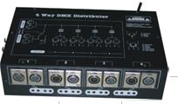  27 |  | DMX-1307 | DMX Distributor | DMX512/1990 Standard  Eight -way DMX distributor with one input  High voltage protection  Independent input and output signal (include earth cable of signal).  Wide input voltage: AC100V-240V 50 / 60Hz | $96,00 | 8 CHL output | $137,00
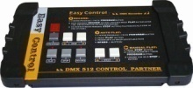  28 |  | DMX-1308 | DMX recorder | 7 different programmes can be saved and selected  The sequency of program speed can be changed  Run the program manual or automatically  Storage up to maximum 7 different programmes with maximum 127 each | $97,00 |  | $139,00
29 | 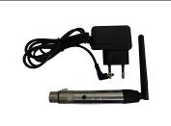 | DW-1 | Wireless DMX Receiver /Transmiter | DMX512 wireless receiver/transmitter  Working frequency：2.4G ISM  Communication distance：400M（visible distance） | $35,00 |  | $50,00
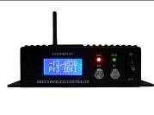  30 |  | DW-2 |  |  | $44,00 |  | $63,00
31 | 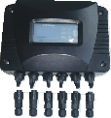 | DMX-1318 | Outdoor DMX Distributor | IP65 --- outdoor use freely  Input/output DMX signal auto self-test  Hight voltage protection  Independent input/output signal and power supply to protect your console and light fixtures. | $153,00 |  | $219,00
32 | 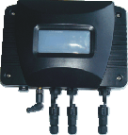 | DMX-1319 | Outdoor Wireless Controller | IP65 --- outdoor use freely  Transmit distance: 300m (Visible distance)  Receiver: Maximum 16 receivers with one Transmitter  DMX channel: 512 CHL (each receiver) | $178,00 |  | $255,00
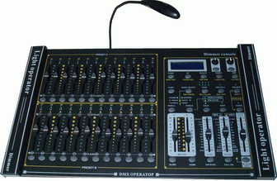  33 |  | DMX-1314 | 24CH Dimmer console | 24-channel DMX-512 dimming console  4 pages with 12 scenes each yields 48 total playback faders(simultaneous playback)  96,000 programmable steps  LED lamp connector | $263,00 |  | $375,00
34 |  | DMX-1315 | 48CH Dimmer console | 48-channel DMX-512 dimming console  8 pages with 12 scenes each yields 96 total playback faders(simultaneous playback)  96,000 programmable steps  LED lamp connector | $312,00 |  | $446,00
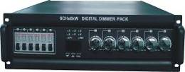  35 |  | DP- 606A |  | 6CH Digital Dimmer Pack,6KW/CH | $446,00 |  | $637,00
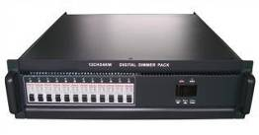  36 |  | DP- 1204 |  | 12CH Digital Dimmer Pack,4KW/CH | $566,00 |  | $809,00
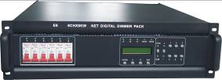  37 |  | DP- 606B |  | 6X6KW Network Digtal Dimmer Pack | $518,00 |  | $739,00
38 | 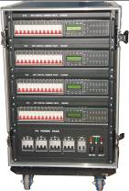 | DP-301 | Flow Silicon Car | 6*6KW Dimmer Pack (4PCS)  24CH Digital Dimmer Pack (1PCS)  P4 Power Pack (1PCS) | $2719,00 |  | $3884,00
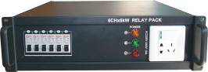  39 |  | ZT-6000 |  | 6CHX6KW Relay Pack | $266,00 |  | $381,00
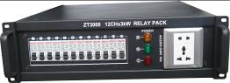  40 |  | ZT-1203 |  | 12CHX3KW Relay Pack | $334,00 |  | $477,00
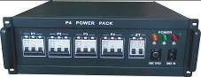  41 |  | P4 |  | POWR PACK | $389,00 |  | $554,00

Все цены в рублях по курсу ЦБ РФ + 2%

